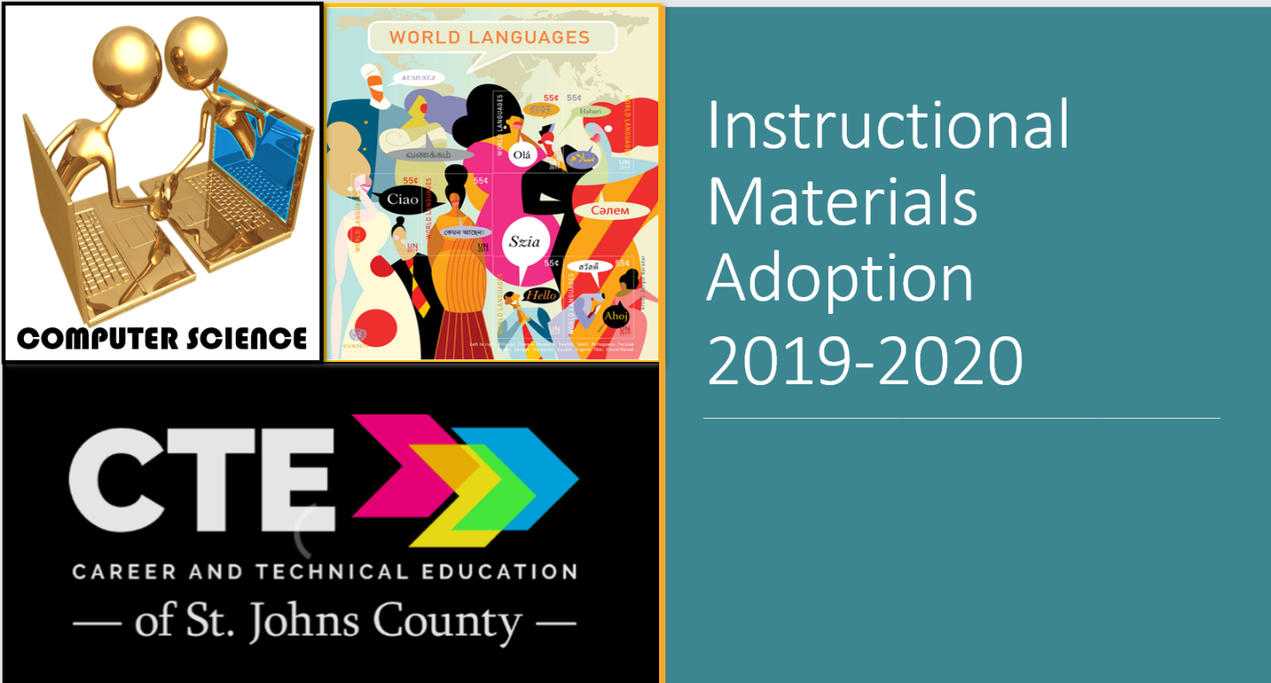

The St. Johns County School District curriculum department representatives and adoption committee members are currently conducting the review process for the 2019-2020 Instructional Materials Adoption for Career and Technical Education, Computer Science, and Foreign Languages resources. Please click here http://www.stjohns.k12.fl.us/media/instructional-resources-media-services/textbooks/adoption/ to obtain access to the resources that are available for review. The core resources that have been submitted for evaluation have come from the state adoption consideration lists when available. Additional resources for programs may be reviewed from materials listed as appropriate for the program indicated. If you are interested in serving on an adoption review committee, please contact the principal or assistant principal.

Resource lists may be revised throughout the review process. Please check the website frequently for updates.

Some print materials may be available for review. If you would like access to available printed materials, or require assistance reviewing the online resources, please call the Instructional Resources and Media Services office at 904.547.3947. Materials are available for review, by appointment, from 8:00 AM – 4:30 PM, when district offices are open.

Please note the following Florida statute regarding instructional materials that pertains to parent input regarding adopted materials:

F.S. 1006.28 (1)(a)(3). Each district school board must establish a process by which the parent of a public school student or a resident of the county may contest the district school board’s adoption of a specific instructional material. The parent or resident must file a petition, on a form provided by the school board, within 30 calendar days after the adoption of the material by the school board. The school board must make the form available to the public and publish the form on the school district’s website. The form must be signed by the parent or resident, include the required contact information, and state the objection to the instructional material based on the criteria of s. 1006.31(2) or s. 1006.40(3)(d). Within 30 days after the 30-day period has expired, the school board must, for all petitions timely received, conduct at least one open public hearing before an unbiased and qualified hearing officer. The hearing officer may not be an employee or agent of the school district. The hearing is not subject to the provisions of chapter 120; however, the hearing must provide sufficient procedural protections to allow each petitioner an adequate and fair opportunity to be heard and present evidence to the hearing officer. The school board’s decision after convening a hearing is final and not subject to further petition or review.

