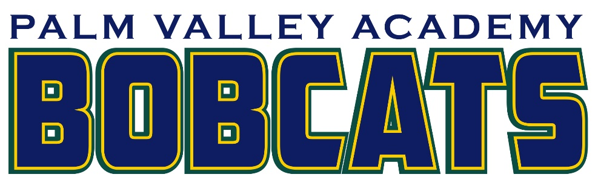

2022-2023 Palm Valley Academy Extended Day Program Rates
 | AM  5 Days | PM  5 Days | AM/PM  5 Days | AM  3 Days | PM  3 Days | AM/PM  3 Days | Wed.  AM/PM
1 Child | $120 | $275 | $341 | $95 | $205 | $240 | $80
2 Children | $210 | $480 | $595 | $165 | $355 | $420 | $140
3 Children | $270 | $620 | $765 | $210 | $455 | $540 | $185
4 Children | $300 | $685 | $850 | $235 | $510 | $600 | $200
Registration Fee:
1 child- $75
2 or more children- $125

*SJCSD Employees receive a 50% discount off rates shown above.
*Active-Duty Military receives a 25% discount off rates shown above.

2022-2023 Fee Schedule
Payment # | Due Date | Payment Coverage
1 | July 15th | August 10 – September 2
2 | Aug 15th | September 6 – September 29
3 | Sept 15th | September 30 – October 26
4 | Oct 15th | October 27 - November 22
5 | Nov 15th | November 28 - December 21
6 | Dec 15th | January 5 - January 31
7 | Jan 15th | February 1 – March 28
8 | Feb 15th | March 1 – April 3
9 | March 15th | April 4 – May 1
10 | April 15th | May 2 – May 25

